Step1 : Install node

Step2: Install visual studio code editor

Step3: Install protractor

$npm install protractor

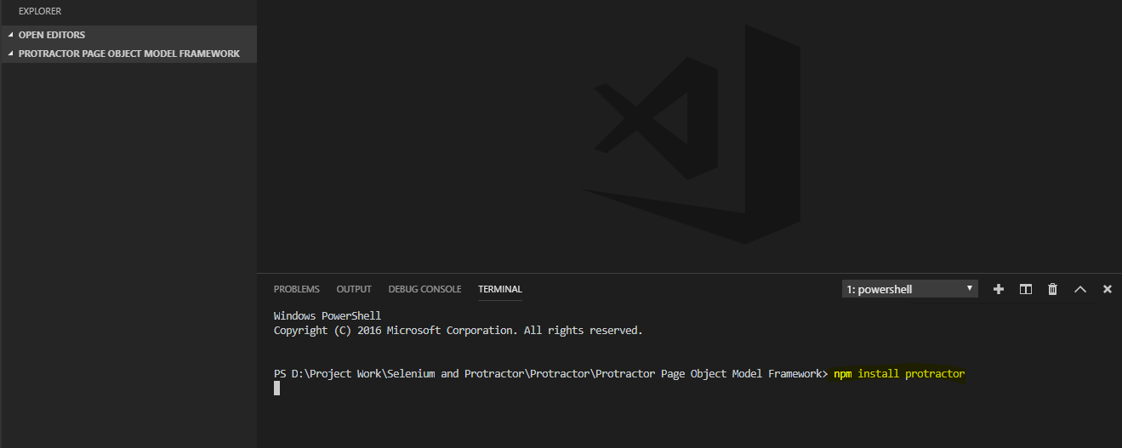

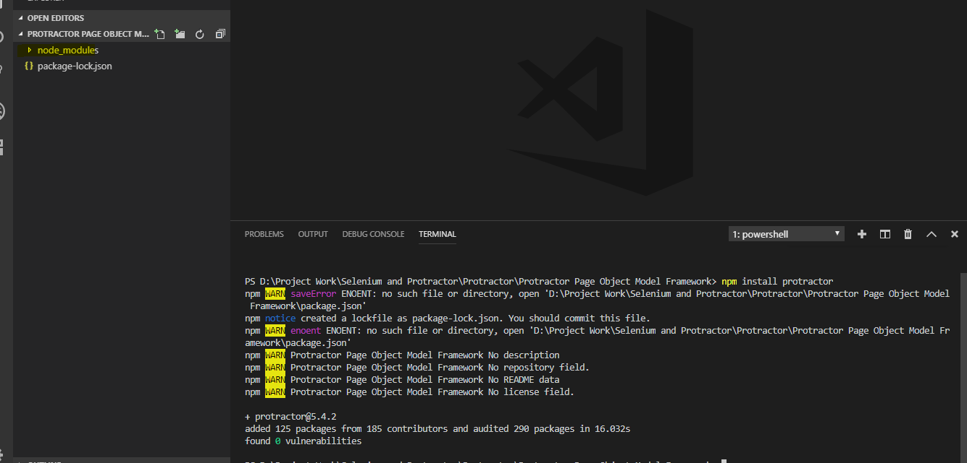

Note: if following error is encountered then we also have to install protractor at global level by using the following command

$npm install -g protractor

Error: protractor : The term 'protractor' is not recognized as the name of a cmdlet, function, script file, or operable program

Step 4: Install jasmine

$npm install jasmine

Step 5: Install typescript

$npm install typescript

Step 6: Install jasmine types:

$npm install –save-dev @types/jasmine

Or

npm install --save @types/jasmine

Step 7: Create the script

Step 8: Create the set up launch:

Follow the following steps:

Click on Debug🡪 Select Add Configuration as follow

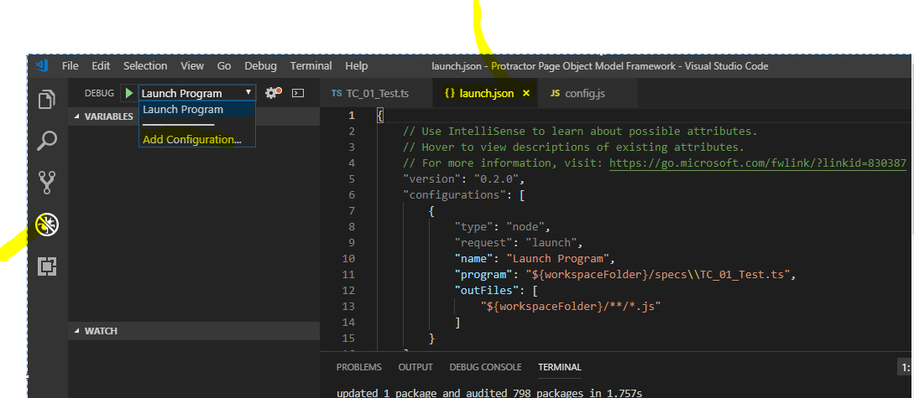

And put the following code in launch.json file

{

"version": "0.2.0",

"configurations": [

{

"type": "node",

"request": "launch",

"name": "Launch Program",

"program": "D:/Project Work/Selenium and Protractor/Protractor/Protractor Page Object Model Framework/node_modules/protractor/bin/protractor",

"args": ["${workspaceRoot}/JSFilesLocation/conf.js"]

}

]

}

Step 11: Configure tsconfig.json as follow:

{

"compilerOptions": {

// "target":"es5",

"target":"es2015",

"module":"commonjs",

"sourceMap": true,

"strict": true,

"outDir" : "outputjs",

"types": ["jasmine","node"]

},

"exclude" : ["node_modules/*"]

}

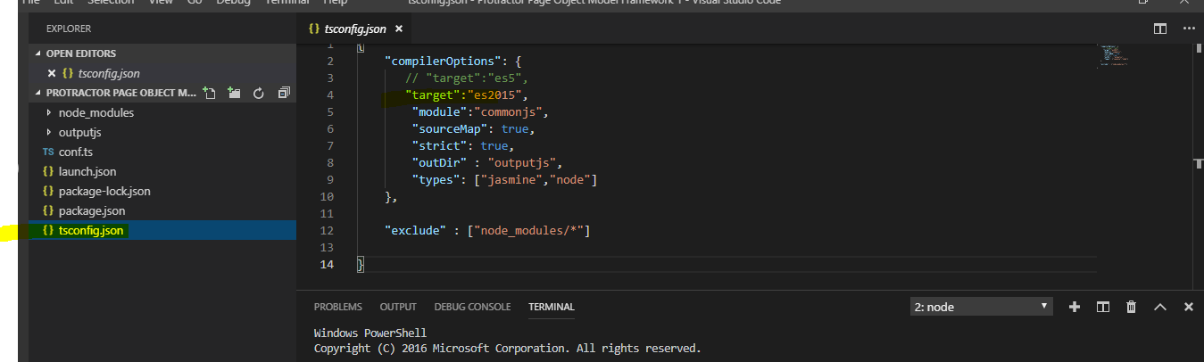

Step 12: Configure package.json as follow:

{

"name": "protractor",

"version": "1.0.0",

"description": "protractor framework",

"main": "index.js",

"scripts": {

"tsc": "tsc",

"pretest": "npm run tsc",

"test": "protractor outputjs/conf.js"

},

"author": "",

"license": "ISC",

"dependencies": {

"@types/jasmine": "^3.3.5",

"chercher-tech-jasmine-reporter": "0.0.7",

"exceljs": "^1.6.3",

"winston": "^3.1.0"

},

"devDependencies": {

"@types/node": "~10.5.2",

"jasmine": "3.1.0",

"protractor": "~5.3.2",

"typescript": "~2.9.2"

}

}

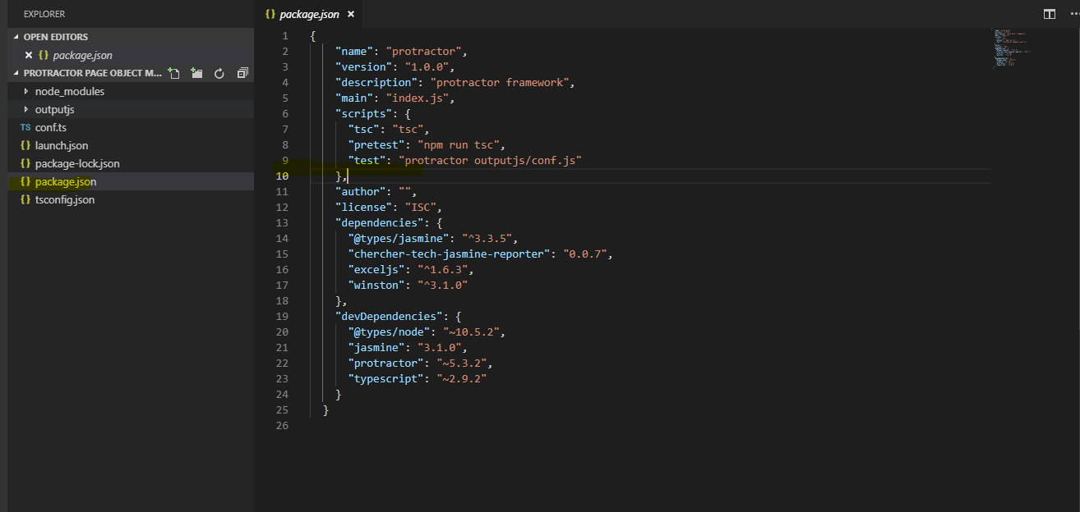

Step 11: Now issue the following command to automatically convert the .ts files into .js file because visual code does not understand .js , it understands only .ts files.

$ tsc –w

Note: if the following error occurred while executing the above command then install the type script at global level by using the following command

$ npm install –g typescript

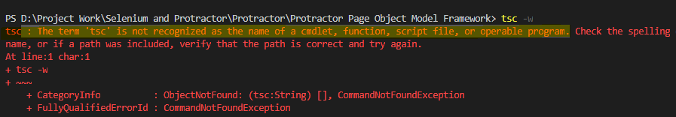

But if again, the following errors while running the command (tsc –w) then install the following by using the following command. It solved my issues.

$ npm install @types/node --save

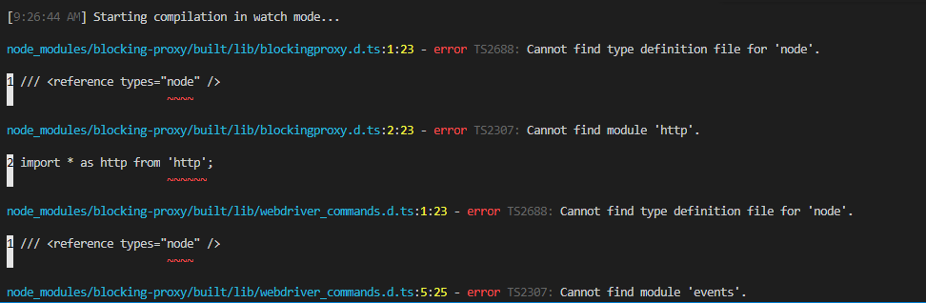

Step 11: Install jars and webdriver

$ webdriver-manager update

Issues: if selenium server is not started and got the following error

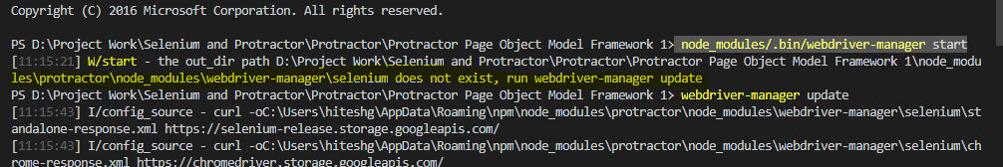

Then update the selenium and it’s driver or its components at the project level by issuing the following command.

$ /node_modules/.bin/webdriver-manager update.

Now issuing the above command, start the selenium server, now it will run successfully.

